Assessment Plan

for
M.S. in Computer Science (CS), and
M.S. in Software Engineering and Information Technology (SEIT)

Department of Computer Science and Engineering
School of Engineering and Computer Science
Oakland University

Overview of the CSE Dept. Assessment Process.
The Assessment process used in the CSE Department has been developed over the years in conjunction with other departments from the school of Engineering and Computer Science and refined to satisfy the relevant accreditation bodies. The assessment plan is driven by the goals and mission of the department which are in line with the goals and missions of Oakland University and those of the SECS.

Goals and Objectives of the M.S. Programs.

1. Oakland University’s Goals (from Mission Statement)

Programs and activities within the Computer Science and Engineering (CSE) department are in line with the following goals of the Oakland University extracted from the University mission found at http://www4.oakland.edu/?id=1654&sid=106:
- It offers instructional programs of high quality that lead to degrees at the baccalaureate, master’s and doctoral levels as well as programs in continuing education;
- It advances knowledge and promotes the arts through research, scholarship, and creative activity; and
- It renders significant public service.
2. School of Engineering and Computer Science’s Goals (from mission statement)
The School of Engineering and Computer Science mission, found in the school website at http://www2.oakland.edu/secs/, states that the overall mission of the School of Engineering and Computer Science is threefold:
- To provide high-quality undergraduate and graduate programs of instruction in engineering and computer science to prepare graduates for careers in the coming decades,
- To advance knowledge through basic and applied research in relevant branches of engineering and computer science, and
- To provide service to both the engineering profession and public of the State of Michigan.
3. Department of Computer Science and Engineering’s Goals (from mission statement)
The CSE mission, found in the department’s website at http://www.cse.secs.oakland.edu/ oakland.edu/secs/, states that the overall mission of the Department of Computer Science and Engineering is threefold:
- To provide high-quality graduate programs of instruction in Computer Science and Engineering to prepare graduates for careers in the coming decades,
- To advance knowledge through basic and applied research in Computer Science and Engineering, and,
- To provide service to the Computer Science and Engineering profession.

4. Learning Outcomes of the Master programs offered by the CSE Department
The two masters programs were developed to serve the mission of the department and meet the needs of its main constituents. A set of learning outcomes were identified for each of the two master’s programs. Some of the learning outcomes are common to all two programs, whereas others are program-specific. They are listed below.
Learning outcomes common to all Masters programs offered by the CSE department:
The graduates of the two masters programs will
    - have a solid knowledge of the key fundamentals in Computer Science and a detailed understanding of current issues and state of the art in computing;
    - have skills in applying their knowledge and understanding to create computing solutions;
    - be proficient in technical communication; and
    - have high standards of professional and ethical responsibility.
Program-specific Learning outcomes:
The graduates of the M.S. in Computer Science will
    - be prepared to perform research in the area of computer science; and
    - be able to design, verify and certify software-based.
The graduates of the M.S. in Software Engineering and Information Technology will
    - be prepared to perform research in Software Engineering and Information Technology; and
    - be able to solve IT problems through the creation and integration of IT systems.
5. How the Learning Outcomes are met

The CSE Dept. faculty has chosen an embedded approach to program assessment. Key courses have been identified in each of the two M.S. programs where students have the opportunity to demonstrate the achievement of the program outcomes; the sets of key courses are chosen to ensure that all of the program outcomes are demonstrated. Student materials are collected from the key courses that provide evidence that the outcomes have been achieved. External evaluators, including faculty not directly involved with the course and departmental advisory board members, review these materials to establish whether the students in that class have achieved some or all of the program outcomes. Every semester, the CSE Dept. faculty review the results of these external evaluations and generate appropriate plans to improve the achievement of the program outcomes.

Each CSE course has a set of course outcomes, developed by the instructing faculty and CSE Graduate Committee, which ensure the logical sequence of topics necessary to the eventual achievement of the program outcomes. At the end of each semester, the students and faculty in each course rate how well that particular course section achieved its objectives. The faculty identifies the specific program outcome(s) achieved in the course and provide evidence in support of their contention. In addition, students and faculty are encouraged to comment on how well the course fits into the overall scheme of the program and to suggest improvements to the course, the course outcomes and the overall program of study. The CSE Dept. holds a faculty meeting at the beginning of each semester to review all external evaluations and end-of-course evaluations from the prior semester and develop any needed plan for improvement.

Measures.

The overall success of the M.S.s in CSE is measured by whether the students can demonstrate achievement of all learning outcomes as they graduate. In order to assess the students’ achievement, the CSE Dept. faculty have selected one direct measure and one indirect measure.

Direct Measure. Key courses are identified in each of the M.S. programs where students have the opportunity to demonstrate the achievement of the program learning outcomes. These courses are chosen to ensure that all of the learning outcomes are demonstrated.
When a key course is under review, student materials are collected that provide evidence that the outcomes have been achieved, such as homework assignments, laboratory assignments, project assignment and exams. External evaluators (faculty not directly involved with the course, engineers from industry and CSE Dept. Advisory Board members) review these materials to establish whether the students in that class have achieved some or all of the program outcomes.

The rubric used by the external evaluators is presented in Appendix A. Note that every assignment is not expected to demonstrated competency in all learning outcomes. Hence, a customized rubric containing only the appropriate learning outcomes is generated for each assignment. The rubrics are generated by any CSE Dept. faculty member from the SECS assessment website. The CSE Dept. faculty meet to review the results of these external evaluations and generate appropriate plans to improve the achievement of the program outcomes.

Indirect Measure. Each CSE M.S. course has a set of course outcomes, developed by the instructing faculty and the CSE Dept. Graduate Committee, which ensure the logical sequence of topics necessary to the eventual achievement of the program outcomes. At the end of each semester, the students in each course rate how well that particular course section achieved its outcomes (Appendix B contains an example rubric for CSE 550). The CSE faculty review all of these course evaluations each semester at a department faculty meeting and generate appropriate plans to improve the achievement of the program outcomes.

Documentation of Assessment Process.

All actions taken at each step of the assessment process are documented properly. This record is used by the CSE faculty to evaluate and improve the assessment process.

CSE Dept. Faculty Involved in the Assessment Process.

All CSE Dept. faculty members are involved in the assessment process.
Appendix A - Example External Evaluation Form (Direct Measure)

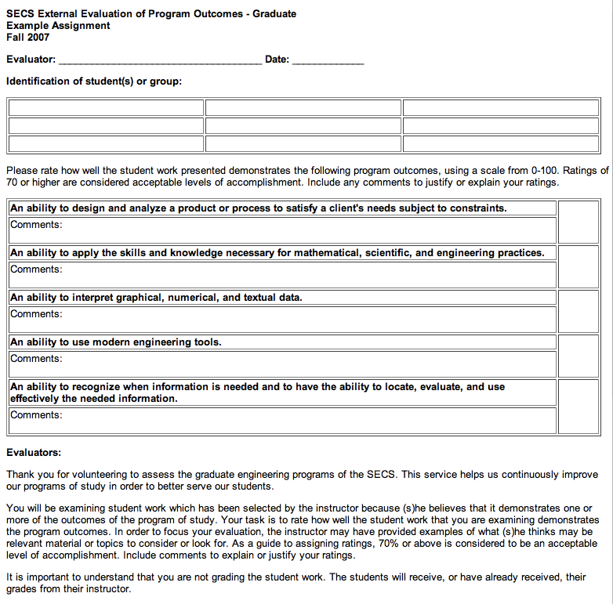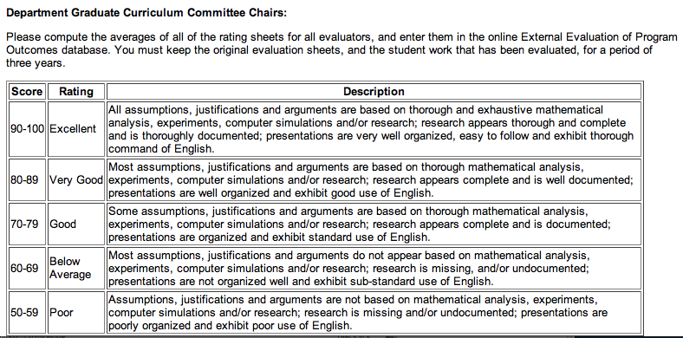
Appendix B – Example Student Evaluation Results (Indirect Measure)

CSE 450 Winter 2008
Class Password: CSE10482
Instructor: Guangzhi Qu
Faculty Rank: Assistant Professor
Below are the Course Objectives, Ratings: (E=EXCELLENT; G=GOOD; A=AVERAGE; P=POOR; U=UNSATISFACTORY; NA=DOES NOT APPLY), Total Ratings, the Average Grade, and the Total Average Grade for course objectives. The numbers below each rating are the total number of students who gave that rating for the course objective.
Course Objectives | E | G | A | P | U | NA | Total Ratings | Median | Standard Deviation | Avg Grade
1. Describe what characterize an OS, what they do and how they are designed and constructed
2. Recognize and distinguish the hardware parts that are necessary to understand an OS
3. Define a process (or a thread) and the notion of concurrency correctly since they are the heart of modern operating systems
4. Distinguish between OS processes and user processes
5. Describe methods for process scheduling, inter-process communication, process synchronization and deadlock handling
6. Describe the role of the main memory for a process execution and the algorithms related to memory management including virtual memory
7. Compass the file-system interface features such as file attributes, directory structure, acyclic graph directories and file sharing
Total Average Grade for Course Objectives =

Below are the Section Objectives, Ratings: (E=EXCELLENT; G=GOOD; A=AVERAGE; P=POOR; U=UNSATISFACTORY; NA=DOES NOT APPLY), Total Ratings, the Average Grade, and the total grade for the section objectives. The numbers below each rating are the total number of students who gave that rating for the section objective.
Section Objectives | E | G | A | P | U | NA | Total Ratings | Median | Standard Deviation | Avg Grade
Below are the Evaluation Questions, Ratings: (E=EXCELLENT; G=GOOD; A=AVERAGE; P=POOR; U=UNSATISFACTORY; NA=DOES NOT APPLY), Total Ratings, Your Rank, the Average Grade, and the Total Average Grade for each question. The numbers below each rating are the total number of students who gave that rating for the question. The Rank column provides your ranking for that specific question out of the total number of rankings (not necessarily the total number of instructors) for that question. For instance, if there are 5 instructors and 2 of them receive a rank of 1, then the total number of rankings is 4.
Evaluation Questions (Ratings) | E | G | A | P | U | NA | Total Ratings | Rank | Median | Standard Deviation | Avg Grade
1. Making the objectives of the course clear to me.
2. Developing and presenting the course material in a clear and organized manner.
3. Stimulating and deepening my interest in the subject.
4. Motivating me to do my best work.
5. Explaining and clarifying difficult material and problem solutions.
6. Willingness to provide individual assistance to students outside of classroom hours.
7. Ability to handle questions from the class.
8. Utilization of class time.
9. Utilization of instructional aids such as blackboard, slides or viewgraph.
10. Uniformity and impartiality in grading.
11. Promptness in returning homework, laboratory reports and examinations.
12. Overall rating as a teacher
13. Value of the textbook contribution to the course
14. Value of the recitation component of the course.
15. Value of the laboratory component of the course.
16. Adequacy of the computing and/or laboratory facilities.
17. Overall rating of this course as a learning experience.
Total Average Grade for Instructor Evaluation Questions =
*Note: Again, more than 1 instructor can have the same rank. (For example: If 4 out of 100 instructors receive a grade of 4.0, then all 4 instructors receive a rank of 1.)
Below are the Evaluation Questions and the students responses to each question.
Evaluation Questions (Comments)
18. INSTRUCTOR
19. COURSE
20. GRADING AND EVALUATION
21. OTHER
Below is the Student Profile section.
Student Profile
1. Hours spent per week outside the classroom for this course. | Over 9 | 6-9 | 4-6 | 2-4 | 0-2 | Total Answer
2. Your assessment of the amount of material covered in this course. | Much Too Much | Too Much | Just Right | Too Little | Much Too Little | Total Answer
3. What grade do you expect to receive in this course? | 3.50-4.00 | 3.00-3.49 | 2.50-2.99 | 2.00-2.49 | Below 2.00 | Total Answer
4. What is your approximate cumulative grade point average? | 3.50-4.00 | 3.00-3.49 | 2.50-2.99 | 2.00-2.49 | Below 2.00 | Total Answer

Below are the final grades for this course section
Course Objective =
Section Objective =
Evaluation Questions =
Final Grade =
Bottom of Form
Top of Form

Goal Cited  in OU Mission | Relevant Goal  of Unit | Student Learning  Outcomes | Methods of Assessment | Individual(s)  Responsible for Assessment Activities | Procedures for Using Assessment  Results to  Improve Program
Programs and activities within the Computer Science and Engineering (CSE) department are in line with the following goals of the Oakland University:  - It offers instructional programs of high quality that lead to degrees at the baccalaureate, master’s and doctoral levels as well as programs in continuing education;  - It advances knowledge and promotes the arts through research, scholarship, and creative activity; and  - It renders significant public service. | A. To provide high-quality graduate programs of instruction in Computer Science and Engineering to prepare graduates for careers in the coming decades,  - To advance knowledge through basic and applied research in Computer Science and Engineering, and,  C. To provide service to the Computer Science and Engineering profession. | The graduates of the two masters programs will  A. have a solid knowledge of the key fundamentals in Computer Science and a detailed understanding of current issues and state of the art in computing;  B. have skills in applying their knowledge and understanding to create computing solutions;  C. be proficient in technical communication; and  D. have high standards of professional and ethical responsibility.  Program-specific Learning outcomes:  The graduates of the M.S. in Computer Science will  E. be prepared to perform research in the area of computer science; and  F. be able to design, verify and certify software-based.  The graduates of the M.S. in Software Engineering and Information Technology will  G. be prepared to perform research in Software Engineering and Information Technology; and  H. be able to solve IT problems through the creation and integration of IT systems. | External evaluation;  Student end-of-course evaluations  External evaluation;  Student end-of-course evaluations  External evaluation;  Student end-of-course evaluations  External evaluation;  Student end-of-course evaluations  External evaluation;  Student end-of-course evaluations  External evaluation;  Student end-of-course evaluations  External evaluation;  Student end-of-course evaluations  External evaluation;  Student end-of-course evaluations | Course instructors and CSE Dept. faculty  Course instructors and CSE Dept. faculty  Course instructors and CSE Dept. faculty  Course instructors and CSE Dept. faculty  Course instructors and CSE Dept. faculty  Course instructors and CSE Dept. faculty  Course instructors and CSE Dept. faculty  Course instructors and CSE Dept. faculty | The CSE Dept. faculty meet each semester to review external and end-of-course evaluations and develop plans for improvement.  The CSE Dept. faculty meet each semester to review external and end-of-course evaluations and develop plans for improvement.  The CSE Dept. faculty meet each semester to review external and end-of-course evaluations and develop plans for improvement.  The CSE Dept. faculty meet each semester to review external and end-of-course evaluations and develop plans for improvement.  The CSE Dept. faculty meet each semester to review external and end-of-course evaluations and develop plans for improvement.

